SICO
Special Event

GASTRIC CANCER
INTERNATIONAL WORKSHOP

A step towards the creation of an European Excellence Network on Gastric Cancer

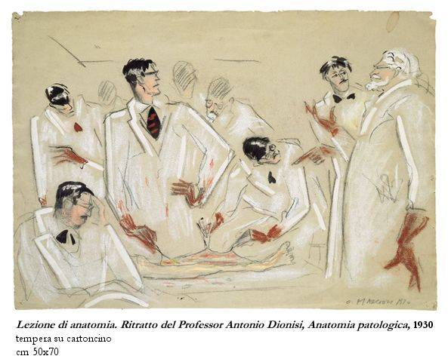

Hosted by the Italian Society of Surgical Oncology

Workshop Chairman : Alfredo Garofalo

Rome, April 1, 2006

Aula Magna , Ospedale Carlo Forlanini
Piazza C. Forlanini,1

Saturday, April 1, 2006

8.30: Opening

8.45 – 9.30 The European Community funding of cooperative research, excellence networks and individual trials.

Session 1: Biology and Surgery – The unanswered questions
Chairmen: D. Nitti (It),
9.30 – 11.00 Modern prognostic factors: genomics, proteomics and future perspectives of
multiarrays
A. Scarpa (It)
Experts Panel: G. Galizia (It), G. Keller(Ger), R. Seruca (Por)

11,00 – 11.45 Dysplasia: follow up or treatment?
M. Rugge (It)
EMR : Indications and perspectives
G. Costamagna (It)
Experts Panel:

11.45 – 12.00 Sentinel node mapping: why and when.
P. Schlag (Ger)

12.00 – 13.00 Lunch

Session 2: Surgical treatment – Needs for a standardization
Chairmen: J. Fielding (U.K.), A. Garofalo (It)
13.00 – 15.00 R0 Resection: is there a need for a new definition ?
D. D’Ugo (It)
The lesson of the major European surgical trials
P. Mc Cullock (U.K.)
Experts Panel: M.De Giuli (It), H. J. Meyer (Ger), C. Van de Welde (Neth), H. Sue Ling (U.K.)

Session 2: Integrated treatments - Search for new models
Chairmen: G.M. Fiorentini (It), S. Cascinu (It)
15.00 – 16.30 Primary chemo therapy
C. Schumacher (Ger)
Primary radio – chemo therapy
V. Valentini (It)
Experts Panel: W. Allum (U.K.), G. Beretta (It), M. Hallissey (U.K.), C. Sternberg (It)

16.00 – 17.00 Prevention of peritoneal recurrences
F. Cavaliere (It)
Discussants: P.P. Cagol (It), F. N. Gilly (Fr), S. Guadagni (It),
17,00 – 18.00 Final remarks

Closure

Registration:

First Name………………………………
Last Name………………………………
Degree(initials)……………..
Address…………………………..
City……………………….State……………………….
Zip Code……………… Country…………………
Phone………………………Fax……………………
e-mail………………………….specialty………………….

The registration fee : € 125
To be sent by
Bank wire transfer
Check

In favour of:
Technai srl
Via del Mascherino, 78 – 00193 Roma
Banca Popolare del Lazio Ag 5 – Roma
c/c n. 984-50 ABI 5104 CAB 3205

The registration fee includes lunchs, breaks and syllabus of the main presentations.

Dear Colleagues,

on next April 1st 2006 an International Workshop on Gastric Cancer will take place in Rome, in the “Aula Magna” of Forlanini Hospital, hosted by S.I.C.O., the Italian Society of Surgical Oncology.
In view of the opportunities offered by the next 7th Framework Program of the European Community and in the need of overcoming the fragmentation of European researchers in our peculiar and multidisciplinary field of interest, the aim of the Workshop is to gather the European representatives of excellence in order to identify possible areas of cooperative investigation.
The main topics were selected following a number of informal meetings which indicated a series of unanswered questions, together with new directions for basic research and innovative models for extended treatment trials.
Each topic will be introduced by a short lecture based on the speakers’ personal data and on published evidence: presentations should be expecially focused on possible cooperative studies and on proposals of multi-institutional trials , to be discussed with the faculty and the audience.
The final goal should be the first constitutive step towards the creation of an European Excellence Network on Gastric Cancer, which could be supported “per se” by the Research Programs of the E.C. .
Looking forward to receiving your comments , hopefully together with your acceptation,
warmest personal regards.
Sincerely
Firma mia

Organizing Committee: A. Garofalo (S.I.C.O. vice-President )
M. Valle , F. Cavaliere
Divisione Chirurgia Oncologica – Ospedale San Camillo-Forlanini - Roma
Tel : +39 06 58703210/3090

Scientific Committee: M. Catarci (Rm)
F. Cavaliere (Rm)
M. Degiuli (To)
D. D’Ugo (Rm)
A. Garofalo (Rm)
M. Valle (Rm)

Secretariat: Technai srl
ADDRESS - PHONE

The developments of Scientific Programme will be published on the website:
www.scamilloforlanini.rm.it/chironco

